Week 10: Bacterial Growth

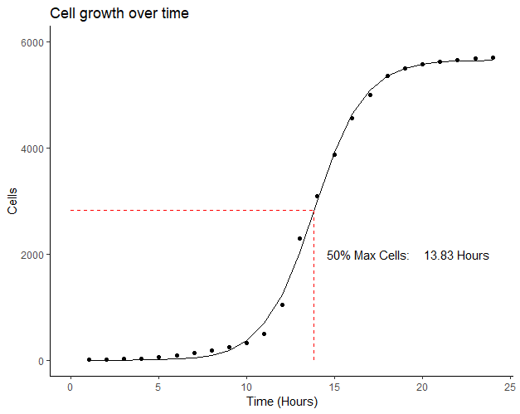

######################

## Bacterial growth ##

######################

## Load ggplot2.0

library**(**ggplot2**)**

## Load data from CSV file

growth.dat **<-** read.csv**(**"growth.csv", sep **=** ',', header **=** T**)**

## Plot the data to provide estimates for the NLS starting vals

ggplot**(**data **=** growth.dat, aes**(**x **=** time, y **=** cells**))** **+**

geom_point**()** **+**

geom_hline**(**yintercept **=** **(**max**(**growth.dat**$**cells**)** **-** min**(**growth.dat**$**cells**))** **/** 2**)** **+**

theme_bw**()**

# midx ~ 14

## Define the formula used in the NLS

growth.formula **<-** **function(**L, K, time, midx**)**

**{**

tmp **=** L **/** **(**1**+**exp**(-**K**\*(**time**-**midx**)))**

return**(**tmp**)**

**}**

# midx - X-value of the sigmoid midpoint

# L - y-assymptote

# K - curves gradient

## Starting values used in the NLS

start.vals **<-** list**(**midx **=** 14,

L **=** 5701,

K **=** 1**)**

## Growth model

growth.nls **<-** nls**(**cells **~** growth.formula**(**L, K, time, midx**)**,

data **=** growth.dat,

start **=** start.vals**)**

x.seq **<-** c**(**1**:**24**)**

growth.pred **<-** predict**(**growth.nls, list**(**time **=** x.seq**)**, se.fit **=** T**)**

growth.pred.frame **<-** data.frame**(**time **=** x.seq, cells **=** growth.pred**)**

## NLS formula final

get.cells **<-** **function(**x**)**

**{**

tmp **=** coef**(**growth.nls**)[[**2**]]** **/** **(**1**+**exp**(-**coef**(**growth.nls**)[[**3**]]*(**x**-**coef**(**growth.nls**)[[**1**]])))**

return**(**tmp**)**

**}**

## Final plot

ggplot**(**data **=** growth.dat, aes**(**x **=** time, y **=** cells**))** **+**

geom_point**()** **+**

geom_line**(**data **=** growth.pred.frame, aes**(**x **=** time, y **=** cells**))** **+**

theme_classic**()** **+**

labs**(**title **=** "Growth of Bacteria over a Day",

x **=** "Time (Hours)",

y **=** "Cells"**)** **+**

lims**(**x **=** c**(**0, 24**)**,

y **=** c**(**0, 6000**))** **+**

annotate**(**"segment",

x **=** coef**(**growth.nls**)[[**1**]]**,

xend **=** coef**(**growth.nls**)[[**1**]]**,

y **=** 0,

yend **=** get.cells**(**coef**(**growth.nls**)[[**1**]])**,

colour **=** "red",

linetype **=** 2**)** **+**

annotate**(**"segment",

x **=** 0,

xend **=** coef**(**growth.nls**)[[**1**]]**,

y **=** get.cells**(**coef**(**growth.nls**)[[**1**]])**,

yend **=** get.cells**(**coef**(**growth.nls**)[[**1**]])**,

colour **=** "red",

linetype **=** 2**)** **+**

annotate**(**"text", y **=** 2000, x **=** 17, label **=** "50% Max Cells: "**)** **+**

annotate**(**"text", y **=** 2000, x **=** 22, label **=** "13.83 Hours"**)**